Creating IAM Policies

Lab Details:

1. This lab walks you through the steps to Create IAM Policies
2. AWS Region: **US East (N. Virginia) us-east-1**

Architecture Diagram:

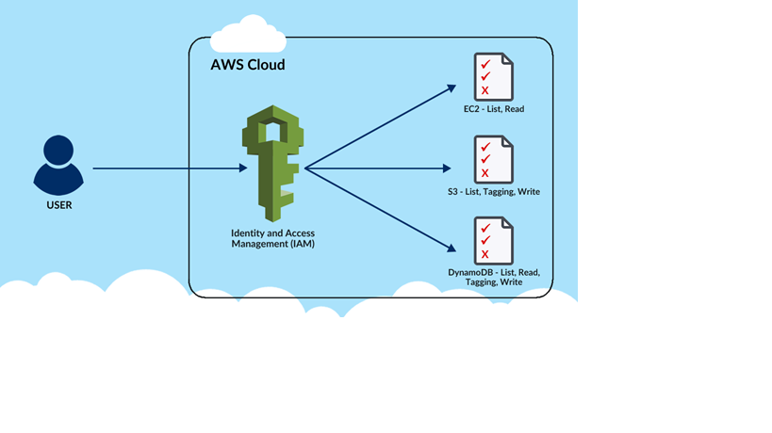

Task Details:

1. Login to AWS Management Console.
2. Create IAM Policy for EC2.
3. Create IAM Policy for S3.
4. Create IAM Policy for DynamoDB.
5. Validation of the lab